The “Feed Haiti” Initiative Story
Poverty is a determined adversary, born in ignorance and fed by apathy. Hunger and dread are its allies. Together they sap the very spirit and will of our humanity leaving only a nagging emptiness and a craving want.
Even though most of us are blessed with the capacity to help another, we often get caught up in the busyness of life. Our day-to-day pressures can be quite taxing, keeping our focus on living our lives and taking care of those closest to us. But there's an entire other world that cries to us from a distance. It is a world filled with hunger.
Each morning when young people awake in America they walk sleepy eyed into their kitchens and are often greeted by their mothers or fathers who prepared for them a nutritious breakfast. There are those exceptions certainly. But even in America, there are many organizations and government support programs to fill the void for those who are encased in abject poverty. In countries like Haiti, these safety nets are non existent.
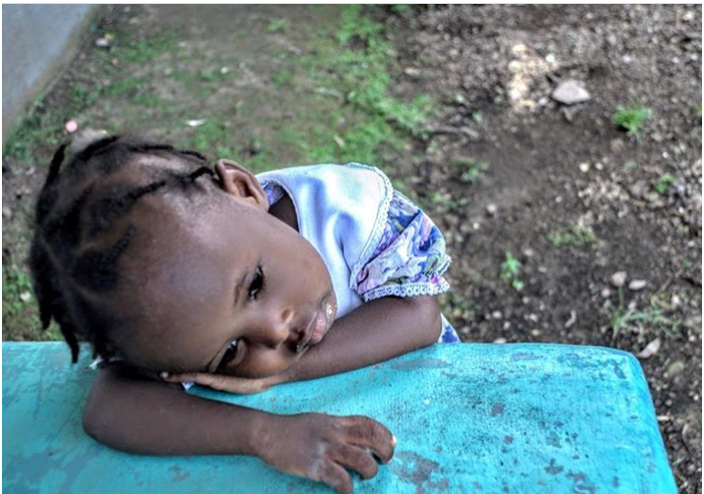
Haiti Health Promise has made the commitment to change that for many people, young and old, who live in the shadow of Bonnet à l'Evêque, the “Bishop’s Hat”, that great promontory that towers to the South of Milot.
So far this year, through the efforts of the Feed Haiti initiative, over 500,000 meals have been sent to the Milot, Haiti region to help break the cycle of hunger. These meals were packaged during events called Packathons where hundreds of caring individuals across the country came together raising enough money and giving a few hours of their time to insure that hunger has a viable competitor going forward. Through their grace, simple but nutitious meals of rice, a blend of dehydrated vegetables, soy and a specialy engineered vitamin additive are showing up in tiny little villages that dot the lanscape just beyond the whitewashed walls of Hôpital Sacré Coeur.

Each meal costs about 35 cents to package and ship to our beleguered sisters and brothers living on a small island 750 miles from Miami. Each meal is a love letter to people who you will never meet or witness their joyful celebration that accompanies the arrival of this precious mana.

The time, treasure and talent it takes to alter the inevitable to a prospect of change is a small investment in the future of humanity and its determined desire to survive its most desperate challenges. The Haiti Packathons are an incredible tool in the arsenal of hope. Please respond to the cry of the poor and be generous by offering your light in the darkness of despair. Stay tuned for announcements of upcoming events in your area and if you would like more information about how to host one of these inspiring Packathons, contact Tim Traynor, the Feed Haiti Program Director at Tim.Traynor@crudem.org or 413.388.0495.

